October 31, 2022

**BCS203193**

MUHAMMAD HARRIS – SECTION 4

Computer Organization & Assembly Language LAB

LAB 05 Practice Task

Practice Task

# Task 01

## **Write an assembly language program using the Loop instruction to print all letters from A to Z.**

## Answer:

.MODEL SMALL

.CODE

;cl = 26

mov cl, 26

;dl = A

mov dl, 65

;loop will run 26 times according to cl

l1:

;print alphabet

mov ah, 02

int 21h

;incement alphabet

inc dl

loop l1

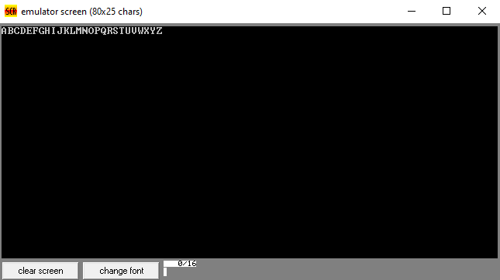

# Task 02

**Write an assembly language program using the Loop instruction to print all letters from a to z.**

## Answer:

.MODEL SMALL

.CODE

;cl = 26

mov cl, 26

;dl = a

mov dl, 97

;loop will run 26 times based on cl

l1:

;print alphabet

mov ah, 02

int 21h

;increment alphabet

inc dl

loop l1

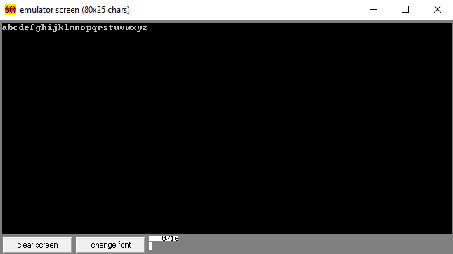

# Task 03

# **Write a program to that reads 10 numbers from user and print the highest number. Use loop to read number 10 times and compare number with the highest in loop?**

## Answer:

.model small

;data segmeny

.data

;message variable

msg db 0ah,0dh,'HIGHEST NUMBER: ','$'

.code

;move data segment to ds register

mov ax, @data

mov ds, ax

;cl = 10

mov cl, 10

;Highest variable = 0

mov bl, 0

;loop will run 10 times

l1:

;input number

mov ah, 01

int 21h

;compare number with highest input

cmp al, bl

;if (al >= bl)

jae c1

;else

jmp c2

c1:

;move number to highest variable

mov bl, al

c2:

loop l1

;print message

mov ah,09

lea dx,msg

int 21h

;print highest variable

mov ah,02

mov dl,bl

int 21h

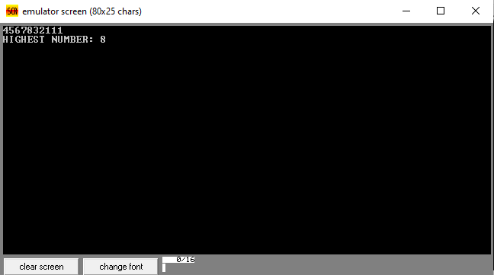

# Task 04

**Write a program to print 0-9 in reverse order?**

## Answer:

.MODEL SMALL

.CODE

;cl = 10

mov cl, 10

;dl = 9

mov dl, 57

;loop will run 10 times

l1:

;print number

mov ah, 02

int 21h

;decrement number

dec dl

loop l1

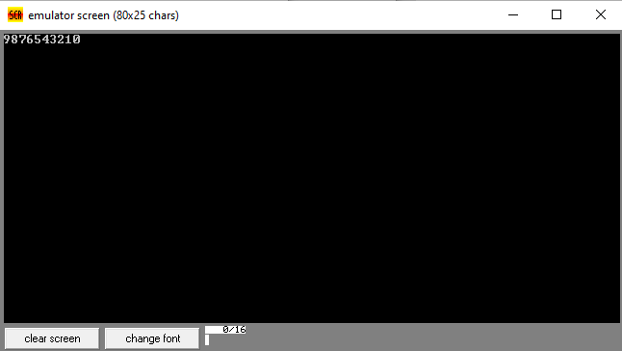

# Task 05

**Write a program to print first five odd numbers in reverse order?**

## Answer:

.MODEL SMALL

.CODE

;cl = 5

mov cl, 5

;dl = 9 which is 5th odd number

mov dl, 57

;loop will run 5 times based on cl

l1:

;print odd number

mov ah, 02

int 21h

;move to next odd number

sub dl,2

loop l1

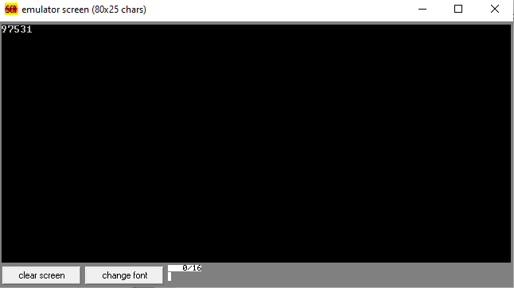

# Task 06

**Write a program to print first five even numbers in reverse order?**

## Answer:

.MODEL SMALL

.CODE

;cl = 5

mov cl, 5

;dl = 8 which is last even number

mov dl, 56

;loop will run 5 times based on cl

l1:

;print even number

mov ah, 02

int 21h

;move to next even number

sub dl, 2

loop l1

